Assignment -4b

Title: To study and implement Delta Learning Rule in MATLAB.
Theory:
- The delta rule is a gradient descent-learning rule for updating the weights of the artificial neurons in a single-layer perceptron. It is a special case of the more general backpropogation algorithm.

- The delta rule is derived by attempting to minimize the error in the output of the perceptron through gradient descent.

- In order to get around the Perceptron’s limitations researchers began developing neural networks with an extra hidden layer of neurons between the inputs and outputs. This hidden layer provided a pool of units to help process data. However, the Perceptron rule did not easily extend to multiple layers. An alternative but related approach to the perceptron learning rule is known as the delta rule. While the perceptron training rule is based on the idea of modifying weights according to some fraction of the difference between the output and target, the delta rule is based on the more general idea of "gradient descent".

- For neuron ‘j’, with Transfer function f(net), the delta rule for j’s i’th weight ‘W_{ji}’ is given by the formula:
∆W_{ji} = α(T_{j}-O_{j})f’(net_{j})X_{j} ;
Where ‘α’ is Learning Rate, ‘f(net)’ is transfer function, ‘T’ is Target, ‘O’ is the actual output, ‘X’ is the input.
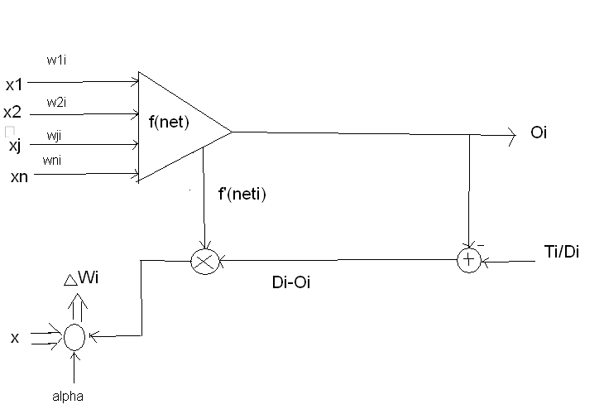
Figure (1)

Algorithm:
- Select an input pattern I_{i}.
- Compute the Multiplication of Input Ii and weight vector W_{i}.
- For Delta Learning we have used Bipolar sigmoid as transfer function.
- Output of transfer function is calculated.
- Then Derivative of output of Transfer Function is calculated.
- Delta learning law is given by,
∆W_{ji}=α(T_{j}-O_{j})f’(net_{j})x_{j.}
7. Update the weights by the formula
W(new)=W(old)+ ∆W_{ji}
8. Do steps (1) to (7) for the entire input pattern.

Bipolar Sigmoid Transfer Function. :-
F(x)
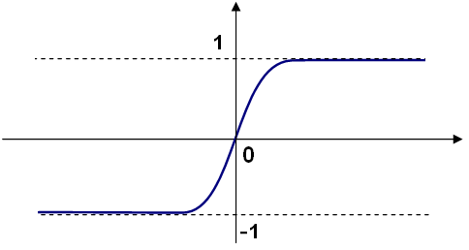
Figure (2)
So,
F(x)= [2/(1+e^(-x))]-1
F’(x)= ½[1+F(x)][1-F(x)]

